Kokopelli Local Rules
Lift, Clean, and Place: We are playing under these rules. See the last page.
Bunkers: Kokopelli does not maintain their bunkers and considers all bunkers as ground under repair. Many bunkers have temporary water in them. See the discussion on this topic. Maybe bring an extra towel for cleaning mud off your ball.
Water: All water hazards are considered lateral hazards (𝅛 red penalty areas 𝅛).
Remember that the SRPGA has adopted USGA Local Rule B-2 Relief on Opposite Side of Red Penalty Area, which gives you an additional option.
Temporary Water (aka/fka, casual water): Free relief. You can always substitute a ball when taking free or penalty relief (or take extra time and clean your ball).
Out of Bounds: Every hole has out of bounds, except maybe 17. Remember that SRPGA has adopted the USGA Local Rule E-5 Alternative to Stroke and Distance for Lost Ball or Ball Out of Bounds. Drop a ball at the edge of the fairway (see discussion).
Power Lines: On some areas of the perimeter and outside of the course are power lines.
Remember that the SRPGA has adopted the USGA Local Rule E-11 Ball Deflected by Power Line. Note: No relief if you hit a power line or pole that is out of bounds.
Lateral Water Hazard (Red Penalty Areas): Relief Options
All options incur a one-stroke penalty. Point X is where the ball crossed the water’s edge.
1. Stroke and Distance Relief.
Play from the original spot.
2. Back-on-the-Line Relief. On a reference line from the pin (hole) straight back through the reference point X, one club length from that line, no nearer the hole than point X.
3. Lateral Relief. From point X, two club lengths, no nearer the hole.
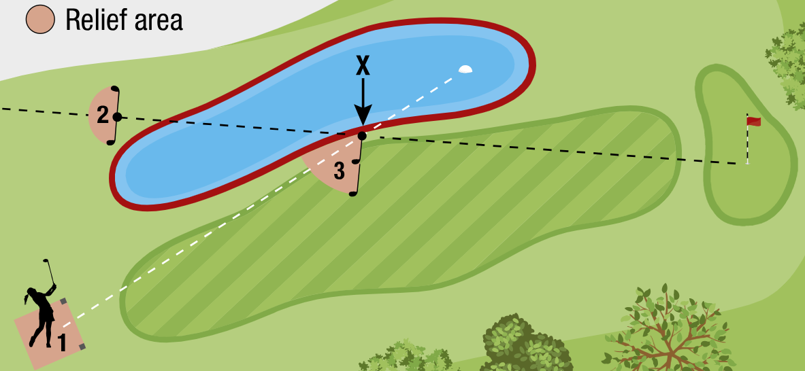
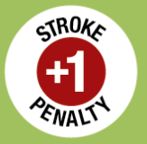

B-2 Relief on Opposite Side of Red Penalty Area
SRPGA Local Rule
4. Opposite Side Relief.
(Similar to lateral relief)
X is where the ball entered the water. On the opposite side of the penalty area, relief at point Y is within two club lengths, no nearer the hole.

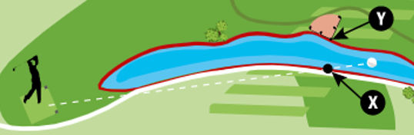
E-5 Alternative to Stroke and Distance for
Lost Ball or Ball Out of Bounds
SRPGA Local Rule
Alternate Relief
(highly encouraged for pace of play issues)
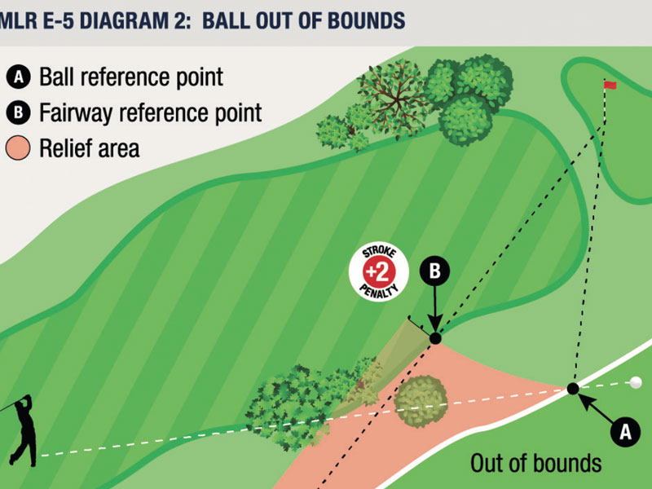
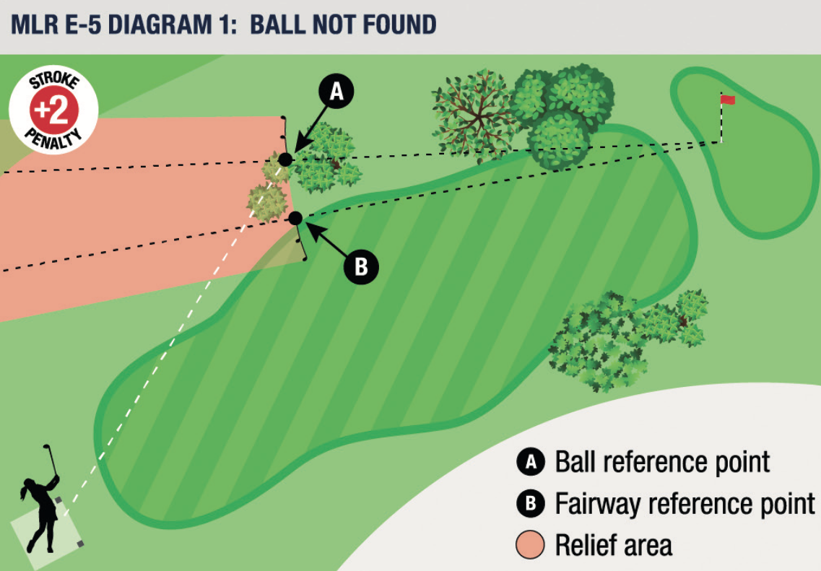
Determine (or estimate) the spot where your ball went out of bounds (top diagram) or is likely to be lost (bottom diagram).
Find the nearest fairway edge, no closer to the hole.
Drop your ball in the shaded area as defined by a line from the hole through point A and on the other side by a line from the hole through point B, and not nearer the hole.
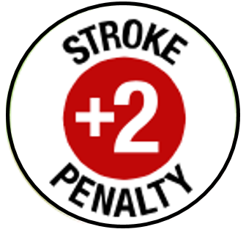
The relief area is extended on both sides by two club-lengths.
Video (1:29) USGA, YouTube
Stroke and Distance Relief
Hit a ball from the original spot. Note: If it is possible that your ball is not out of bounds or lost, you may want to hit a provisional.
E-11 Ball Deflected by Power Line
SRPGA Local Rule
If it is known or virtually certain that a player’s ball hit a power line (or a tower, a wire, or a pole supporting a power line) during the play of a hole, the stroke does not count.
The player must play a ball without penalty from where the previous stroke was made (see Rule 14.6 for what to do).
This rule does not apply for power lines that do not interfere with play of a hole or are out of bounds.

Bunkers
Kokopelli does not maintain their bunkers and considers them ground under repair. You may still play from a bunker, without penalty, if you think dropping a ball outside the bunker would have no advantage for you.
Rule 16 – Relief from Ground Under Repair (a type of “abnormal course condition”)
1. Identify the nearest point of complete relief (put a tee there). In the diagram, it is the reference point:
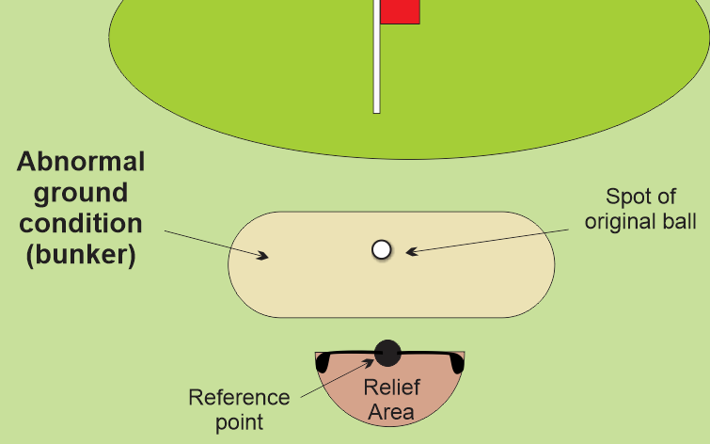
- The estimated point nearest to the ball’s original spot, but not nearer the hole than that spot,
- In the general area, and
- Where the bunker does not interfere
with your stroke.
- Note: If your ball is at the side of the
bunker, nearest relief might be to the side and not the back of the bunker.
2. Drop a ball in the relief area (one club length from the reference point, no nearer the hole).

Lift, Clean, and Place
Note: You cannot substitute another ball in this procedure.
- Mark the spot of your ball (use a ball marker).
If you lift your ball without marking it, you incur a one-stroke penalty.
- Clean your ball.
- Replace your ball on its original spot and remove the marker.
If you forget to remove your marker and make a stroke, you incur a one-stroke penalty.

