 |  | Antelope Hills  Prescott  Sat & Sun July 11& 12, 2020  Payment must be in by  Friday, July 3 Noon |  | Antelope Hills Greg Witherspoon Memorial Tournament
 | Fees | $65 per person per day (Includes green fees, cart, prize fund, skill prizes). Range balls available for purchase.  No entries accepted without entry check or pay on line by the deadline.  ALL PLAYERS MUST NOTIFY tim.camper@srpnet.com who’s playing in group
 | Skins | $5 Individual skins on Sat…$10 Team Skins on Sunday. (Optional)
Format | Saturday: Individual Stroke Play - Shotgun Start at 8:00am on the North Course  Sunday: 2 Man Scramble - Shotgun Start at 8:00am on the South Course  USGA handicapping for scramble: A Player is 35% plus B Player is 15% of their handicaps  Gold Tees Men/Red Tees Women
Directors | Tim Camper 602-739-2277  Becky Harsh 480-967-5058  Randy Smith 480-985-7827 |  | Additional copies of this flyer are available on our internet site at  http://www.srpgolf.com.
Contact/ Location  Driving Range | Randy Picard  1 Perkins Drive, Prescott 1-928-777-1882  Prescott, AZ 86301  Grass; no restrictions |  | How to Get There: I-17 North to exit at Hwy 69 (Cordes Jct.) West on Hwy 69 to Prescott Lakes Pkwy, then right to Hwy 89A. Turn right (North) on Hwy 89 and course is on right.  Prescott Lodging: Prescott Lodging Guide. Consider alternatives in Chino Valley, Prescott Valley.
Paying through America First CU
Payment |  |  | Players Antelope Hills  (Check with them first to see if they are playing.)
Check Enclosed | Online or Phone | Not Known
❑ | ❑ | – | 1.
❑ | ❑ | ? | 2.
❑ | ❑ | ? | 3.
❑ | ❑ | ? | 4.

- Log in to your AFCU acct & make an online transfer.
- Speech Access - Phone1-800-288-
7896 & follow the speech access prompts. SRPGA Acct
3. $65 or $130

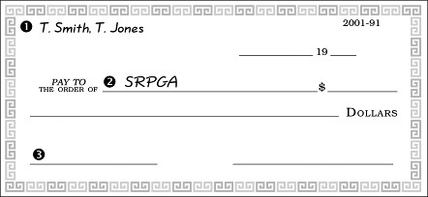
If paying online or by phone, e-mail the registration information to Tim Camper at tim.camper@srpnet.com

Send Check and/or Form to:  SRPGA – CUN280  Salt River Project  P.O. Box 52025  Phoenix, AZ 85072-2025 | - Make check payable to SRPGA  - Absolutely no cash  - On Memo Line Write Prescott

