Parker, AZ Area Information
September 15 & 16, 2018
Average Daily Temperatures for 9/15 & 9/16: High 103, Low 73
July is the warmest month. Average precipitation for the month of September is .48”
LODGING
Blue Water Resort & Casino** https://www.bluewaterfun.com/ 928-669-7000
Best Western** Best Western 928-669-6060
Hampton Inn** Hampton Inn Parker 928-669-1000
Quality Inn** Quality Inn 928-669-2133
Budget Inn Budget Inn 928-669-2566
Harbour Inn** Harbour Inn 928-667-2931
El Rancho Motel** 928-669-2231
1st Canal Vacation home sleeps up to 12 – water front https://www.vrbo.com/915158
Kofa Inn 928-669-2101
Lake Havasu lodging available at approximately 21 miles away
Air BNB – Some are child & pet friendly Air BNB

RV PARKS - the website below lists the websites for all the parks (Note: Most parks are pet friendly)
https://www.bluewaterfun.com/rv-parks/
Blue Water RV Park 928-669-2433 **
Pirate’s Den Resort 928-667-3102
Lazy D Mobile Home Park
La Paz County Park La Paz County Park 928-667-2069
Foxs RV Resort Foxs RV Resort/ 928-667-4100
Verde West RV Park
Branson’s Resort – On the Colorado River
Emerald Cove Resort
Havasu Springs Resort
Riverview Mobile Home & RV Park
** Pet Friendly
RESTAURANTS
Crossroads Café Stroke’s
El Sarape Restaurant Sundance Saloon
Coffee Ern’s (good breakfast) Sundance Saloon
Ruperto’s Mexican Food (late night) Havasu Springs Resort
Mayas’ Restaurant & Sports Cantina Big Belle Subs
Bobby D’s Diner La Piazza Pizza
Roadrunner Floating Dock Bar Tierra Caliente Meat Market (butcher)
Lily’s Mexican Food Early Bird Coffee Shop
Black Pearl Restaurant Parker Dam Diner & Deli
China Garden Restaurant Denny’s
Pirate’s Den Resort
MISCELLANEOUS
In addition there is a Walmart for your every need.
Grocery stores: Food City, Safeway, Walmart
Website for things to do with kids Things to do with kids in Parker

Property Map of the Blue Water Resort & Casino:
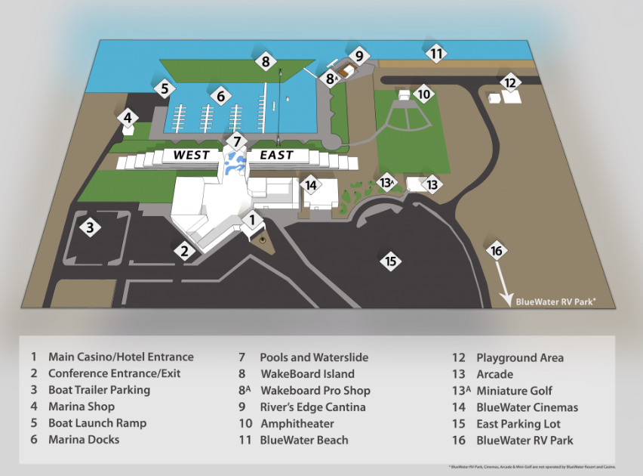

DRIVING INSTRUCTIONS FROM ISB, 1600 N PRIEST DRIVE
